Web Architecture
Microsoft, C#.Net, MVC, Visual Studio

Click here to enter text.
Information Services
October 30, 2020

Contents
Architexture Over view 3
Web Layer: name and place JavaScript files 4
Web Layer: JavaScript patterns 5
Web Layer: JavaScript AJAX 6
Web Layer: Settings 7
Web Layer: Logging 9
Versioning 9
Methodology 9
Versioning in Visual Studio 10

Architexture Over view
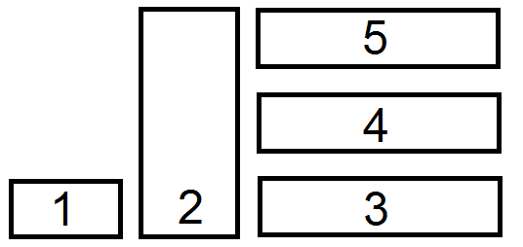

- Unit Test Project or Console Application
Programing Language: C#
This project will contain references to all projects and contain C# code for testing

- Common Layer
Programing Language: C#
This project will contain models and interfaces common to all layers

- Data Access Layer
Programing Language: C# & SQL
This project contains all the database commands for performing CRUD operations to SQL Server

- Business Logic Layer
Programing Language: C# & SQL
This project contains all of the business rules, including user access, server side validation and auditing

- Web Layer
Programing Language: C# (Controllers only), HTML, CSS & JavaScript
The project contains all of the web content. The Web and Logic Layers interface in the Controllers, and no business logic is performed in the Web Layer.

Web Layer: name and place JavaScript files
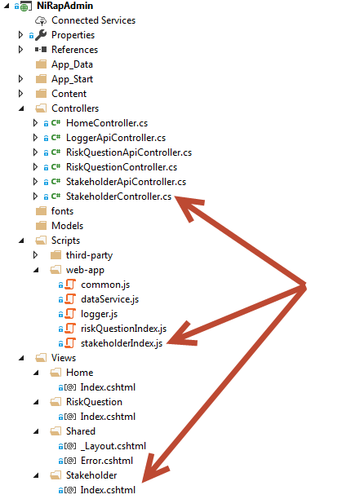 | Microsoft MVC requires the View Folder name to match the controller name.  The View name matches the ActionRequest method name within the controller  CWB coding standards requires  View specific java script be contained in a separate js file  the View js files are named [folder name][view name].js  the View js files are saved in a separate folder from open source third party java script  reusable js code should be written into a common js file, note: the file name doesn’t have to be common.js

Web Layer: JavaScript patterns
stakeholderIndex.js  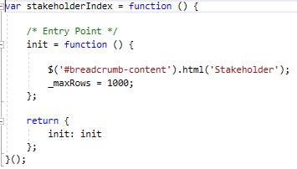  /Stakeholder/Index.cshtml  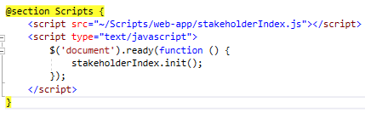 | CWB coding standards requires the View js files use the revealing module pattern:  https://www.pluralsight.com/blog/software-development/revealing-module-pattern-structuring-javascript-code-part-iii

Web Layer: JavaScript AJAX
CWB coding standards requires all AJAX calls be made from a single js file. NOTE: for large web applications, AJAX calls can be grouped into a few separate js files.

The image below demonstrates the relationship between dataServer.js and an API controller

Yellow highlight demonstrates a GET request containing a parameter

Purple highlight demonstrates a POST request containing form data
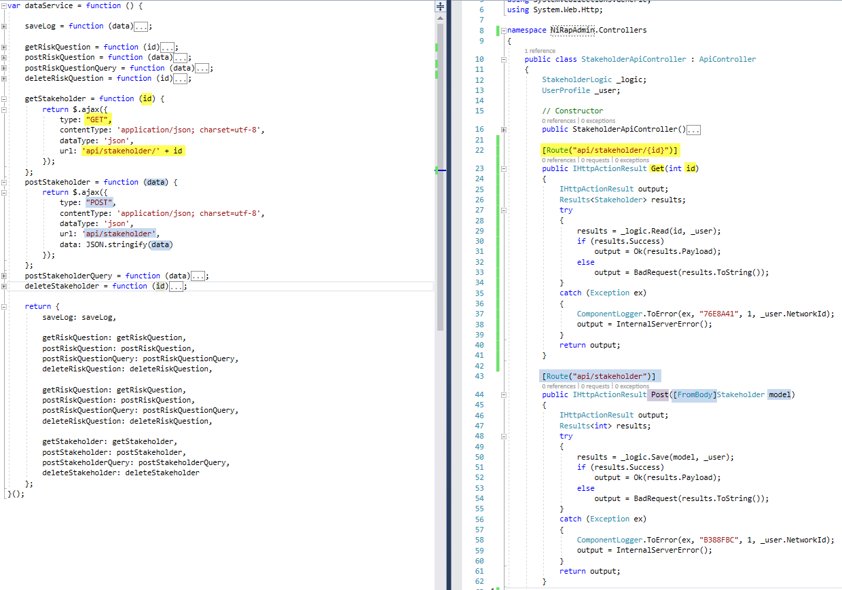

Web Layer: Settings
CWB coding standards prevent developers from programmatically overriding settings normally set using the web.config or IIS Administration Screen in Windows Server

CWB coding standards requires developers to use HTTP status codes. Developers should not develop their own status codes.
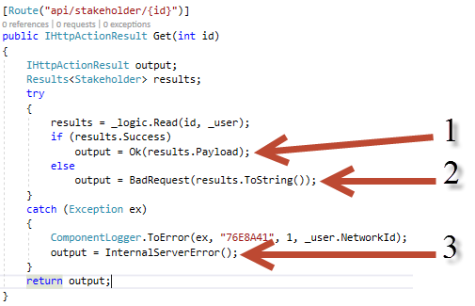
- IHttpActionResult will build a HTTP response with status code 200. Any object, (string, int, array, model) will be serialized into JSON.

- IHttpActionResult will build a HTTP response with status code 400. Any object, (string, int, array, model) will be serialized into JSON.

- IHttpActionResult will build a HTTP response with status code 500.

IHttpActionResult will use the web.config or IIS setting for HTTP(S), TLS, meta data and URL bindings. Some common IHttpActionResult types:
- Ok
- NotFound
- InternalServerError
- Unauthorized
- BadRequest
- Conflict
- Redirect

Web Layer: Logging
Web layer logging has two pieces:
- Logger.js
- LoggerApiController

logger.js called from a Java Script promise
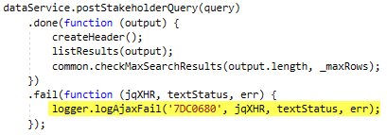

Logger.js will:
- Write a relevant message to the browser console, so the message will be visible using F12 developer tools.
- Display a relevant message toastr popup

POST a relevant message to the server, and LoggerApiController will log the message on the server. The users’ networkId will be written into the server side log file. CWB IS can find the message in Elasticsearch if Filebeats is running against the log folder.

Versioning

Methodology
Use a.b.c.d where
a - Major (adding/modifying more than three (3) module, or adding/modifying functionality that affects the whole application)
b - Minor (adding/modifying more than one (1) module)
c - Revision (bug fixes)
d - Build (updating a build on the server)

Versioning in Visual Studio
- Rightclick on the web project and select ‘Properties’
- Click on ‘Assembly Information’
- Update both versions
